**Talking Points: National Women’s Health Week**

**May 14–20, 2017**

* The 18th annual National Women’s Health Week kicks off on Mother’s Day, May 14 and is celebrated until May 20, 2017.
* The goal of National Women’s Health Week is to remind women to make their health a priority.
* The U.S. Department of Health and Human Services (HHS) Office on Women’s Health (OWH) also encourages women to take simple steps for better health at every age.
* To improve their physical and mental health, women can:
  + Visit a doctor or nurse for a well-woman visit (checkup) and preventive screenings;
  + Get active;
  + Eat healthy;
  + Pay attention to mental health, including getting enough sleep and managing stress; and
  + Avoid unhealthy behaviors, such as smoking, texting while driving, and not wearing a seatbelt or bicycle helmet.
* Women make approximately 80 percent of health care decisions for their families, serving as the primary caregiver for their parents, partners, and children, especially when they become ill.1 When women take care of everyone else, they tend to put their own health and well-being on the back burner.

# *Ages & Stages: Women’s Health Needs Across the Lifespan*

* Women’s health needs change as women age.
* HHS OWH highlights the steps women can take to live healthier lives, no matter their age. For example:
  + Women of all ages should maintain a healthy weight. (In 2011-2014, we know that two-thirds or 66% of adult women were overweight or obese).2
  + Women in their reproductive years — 20s to 40s — should talk to their doctors about family planning — whether they’re planning to have children or not.
  + Women in their 50s should get screened for colorectal cancer.
  + Women in their 60s and 70s should talk to their doctor about osteoporosis screening, and getting the shingles and pneumonia vaccines.
* The screenings and shots you need depend on your age, health habits, risk factors, and family history.
* HHS OWH highlights women’s health needs by decade on womenshealth.gov.

# *Well-Woman Visit & Preventive Care*

* A well-woman visit is a yearly checkup. Women of all ages need one.
* It’s a time to have a conversation with your doctor; check in on your health status, your health goals, and what changes you can make to get there.
* More specifically you’ll:
  + Discuss your family history, family planning, current medications, and personal habits, such as alcohol and tobacco use.
  + Get or schedule necessary shots or tests, such as screenings for blood pressure, cholesterol, and colorectal cancer.
  + Set health goals, such as being active and maintaining a healthy weight.
* If you have health insurance, a yearly well-woman visit won't cost you anything extra.
* If you don't have insurance, you can still see a doctor or nurse for free or low-cost at a health center near you.
* Preventive screenings are needed because these tests help find diseases early, when they’re easier to treat.

# *Physical Activity*

* Only 19% of women met the Physical Activity Guidelines for aerobic and muscle-strengthening activity.3
* Only half of all women get the recommended amounts of physical activity they need.4
* Women need about 2 hours and 30 minutes of moderate-intensity aerobic physical activity each week. That’s about 30 minutes a day.
* Some physical activity is better than none — and any amount has health benefits.5

# *Healthy Eating*

* Diet is one of the most powerful tools we have to reduce the onset of disease. Healthy eating patterns can help prevent obesity, heart disease, high blood pressure, many types of cancer and Type 2 diabetes.6
  + Nearly 2 out of 3 women in the United States die from chronic diseases.
  + Heart disease, for example, is the leading cause of death among American women.7
* A healthy diet is made up of lots of fruits, vegetables, whole grains, low-fat dairy, oils, and lean proteins. Avoid saturated fats, trans fats, added sugars, and sodium.
* We make hundreds of decisions about food each day,8 so there are a lot of chances to eat healthy.
* Try swapping white bread for whole grain bread. Use low-fat or fat-free milk in your coffee instead of cream. Add fruit to the top of your cereal or oatmeal, and add veggies to pasta and sandwiches.

# *Mental Health: General*

* Part of having a healthy body comes from taking care of your mind.
* When you’re in a good mental state, it’s easier to take care of yourself physically.
* Some tips include:
  + Eat healthy. The food you eat can have a direct effect on your energy level, physical health, and mood.
  + Get regular physical activity. It’s been shown to help with the symptoms of depression.9
  + Get plenty of sleep. Your body needs time to rest and heal, and sleep can help with that.9
  + Manage stress. Stress impacts physical and mental health, so it’s important to manage it. Reducing stress is all about taking time for you, **whether it’s taking a long walk, getting a massage, or making time to catch up with a friend.**
* Of course, taking these steps is not that simple for everybody. If you’re having trouble coping, you should talk to your doctor, your family, your friends, or another supportive person.

# *Mental Health: Depression*

* We know that some mental health problems are more common in women than men. For example, women are almost twice as likely as men to experience depression.10
* There are also certain types of depression that are unique to women, such as postpartum depression. CDC research shows about 1 in 9 women experiences postpartum depression.11

# *Mental Health: Substance Misuse*

* We've seen an alarming rise in overdose deaths from prescription painkillers among women in the United States. Between 1999 and 2010, overdose deaths from prescription pain killers increased more than 400% among women, compared to an increase of 265% among men.12
* A unique combination of biological, health, and social factors have led to this growing epidemic among women. For example, according to the CDC, women are more likely to experience chronic pain and to be prescribed opioid pain medications for longer periods and in higher doses than men.13
* And women have risk factors that are unique, or at least more common, for them. Psychological or interpersonal stress has been identified as a greater risk factor for prescription opioid misuse among women.10

# *Safe Behaviors*

* Engaging in safe behaviors, such as not smoking (or quitting smoking), not texting while driving, and wearing a seatbelt or bicycle helmet are important to long-term health and to an overall healthy lifestyle.
* Women are more likely than men to use a handheld device while driving.15
* Fatal crashes involving distracted driving are increasing.16 When you text, the average time your eyes are off the road is five seconds.17 When traveling at 55mph, that's enough time to cover the length of a football field blindfolded.17
* More than 13 of every 100 adult women smoke cigarettes.18 Cigarette smoking is the leading cause of preventable disease and death in the United States.18
* HHS OWH invites everyone to participate in and support National Women’s Health Week. Learn more about National Women’s Health Week at [www.womenshealth.gov/nwhw](http://www.womenshealth.gov/nwhw).
* Use the **#NWHW** hashtag in your social media promotion. Follow **#NWHW** on Twitter.

**Sources** (all accessed on April 11, 2017):

1. U.S. Department of Labor. December 2013. *Fact Sheet: General Facts on Women and Job Based Health*. <https://www.dol.gov/agencies/ebsa/about-ebsa/our-activities/resource-center/fact-sheets/women-and-job-based-health>   
     
   “Women make approximately 80 percent of health care decisions for their families and are more likely to be the care givers when a family member falls ill.”  
     
   or  
     
   *Issue Brief, An Update on Women’s Health Policy: Women, Work, and Family Health: A Balancing Act*. Roberta Wyn, Ph.D. and Victoria Ojeda, M.P.H. of the UCLA Center for Health Policy Research with Usha Ranji, M.S. and Alina Salganicoff, Ph.D. of the Kaiser Family Foundation, published by the Kaiser Family Foundation in April 2003 at <http://www.kdheks.gov/hcf/healthquest/download/resource_downloads/Balancing_Act_Issue_Brief.pdf>   
     
   “Approximately 80% of all mothers are responsible for selecting their child’s doctor, taking children to doctor's appointments, and follow-up care (Figure 1).”   
     
   “Women are the major coordinators of care and the link to the health care system for their families. They play the key role in coordinating and ensuring access to health care for their children. Many women also assume an important role as caregivers of relatives who are sick, disabled, or elderly. These women often care for their families while maintaining employment commitments.”
2. U.S. Department of Health and Human Services (HHS)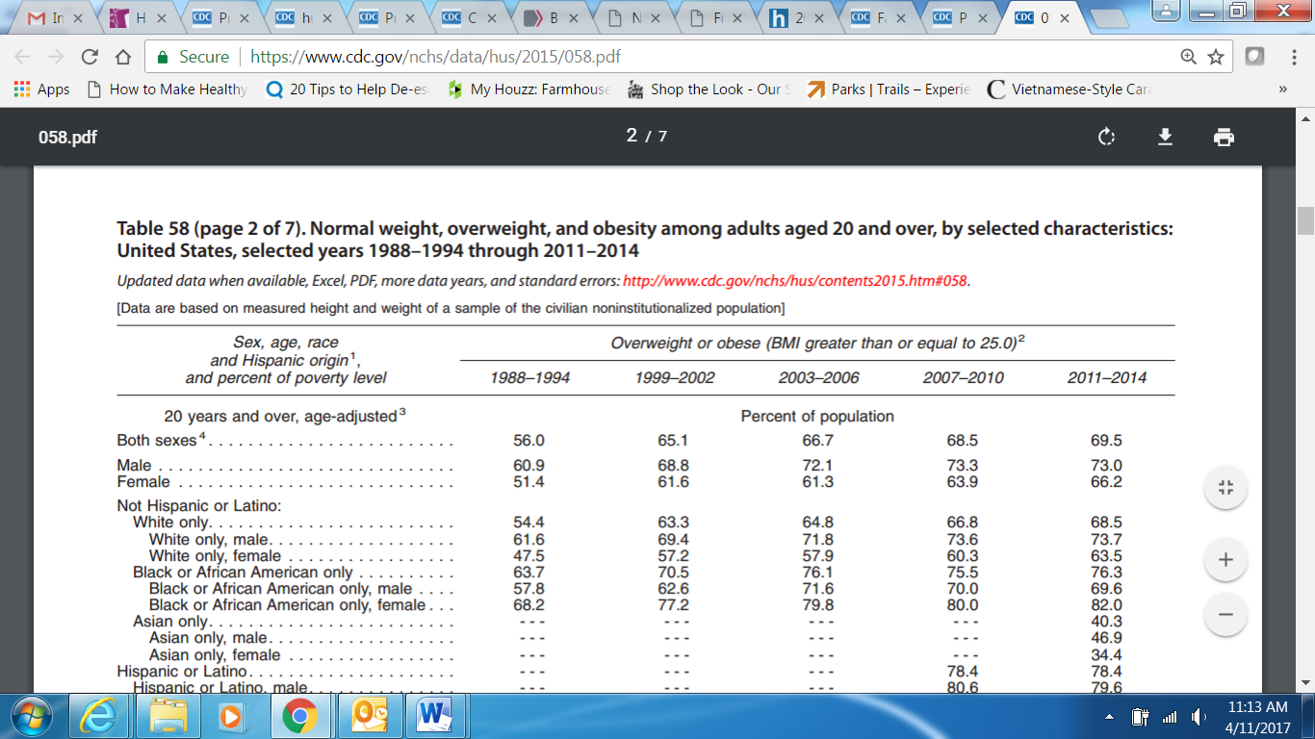, Centers for Disease Control and Prevention (CDC). Published in 2016: *Health, United States, 2015: With Special Feature on Racial and Ethnic Health Disparities*. Table 58 (page 2 of 7). Normal weight, overweight, and obesity among adults aged 20 and over, by selected characteristics: United States, selected years 1988–1994 through 2011–2014. <https://www.cdc.gov/nchs/data/hus/2015/058.pdf> [Screenshot of this table in lieu of a quote]
3. U.S. Department of Health and Human Services (HHS)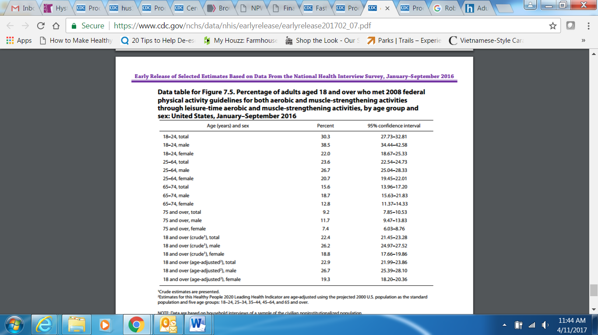, Centers for Disease Control and Prevention (CDC). Published February 2017. *Early Release of Selected Estimates Based on Data From the National Health Interview Survey, January–September 2016*. Data table for Figure 7.5. Percentage of adults aged 18 and over who met 2008 federal physical activity guidelines for both aerobic and muscle-strengthening activities through leisure-time aerobic and muscle-strengthening activities, by age group and sex: United States, January–September 2016. <https://www.cdc.gov/nchs/data/nhis/earlyrelease/earlyrelease201702_07.pdf>   
   [Screenshot of this table in lieu of a quote]
4. U.S. Department of Health and Human Services (HHS), Centers for Disease Control and Prevention (CDC). Published February 2017. *Early Release of Selected Estimates Based on Data From the National Health Interview Survey, January–September 2016*. Data table for Figure 7.2. Percentage of adults aged 18 and over who met 2008 federal physical activity guidelines for aerobic activity through leisure-time aerobic activity, by age group and sex: United States, January–September 2016. <https://www.cdc.gov/nchs/data/nhis/earlyrelease/earlyrelease201702_07.pdf>   
     
   [Screenshot of this table in lieu of a quote]
5. U.S. Department of Health and Human Services (HHS), Office of Disease Prevention and Health Promotion. *2008 Physical Activity Guidelines for Americans*, Chapter 4, Active Adults. <https://health.gov/paguidelines/guidelines/chapter4.aspx>   
     
   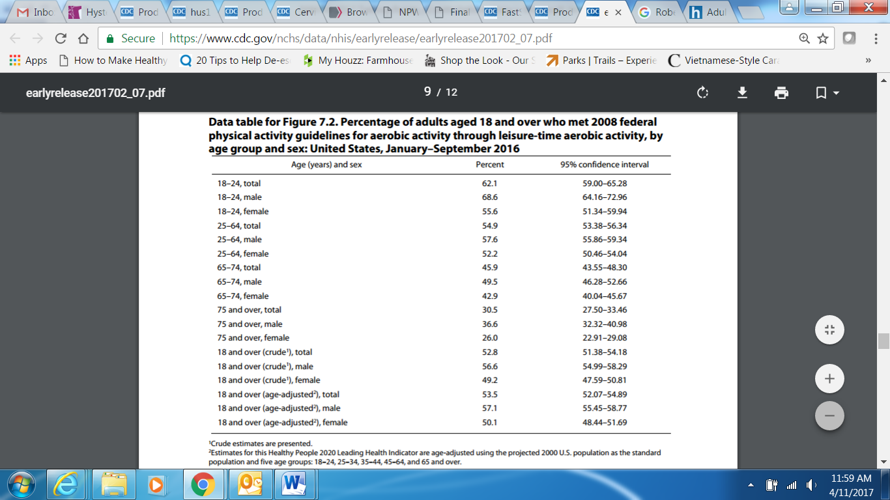“Some physical activity is better than none, and adults who participate in any amount of physical activity gain some health benefits.”
6. U.S. Department of Health and Human Services and U.S. Department of Agriculture. 2*015 – 2020 Dietary Guidelines for Americans*. 8th Edition. December 2015. Available at <http://health.gov/dietaryguidelines/2015/guidelines/>.  
     
   “Strong evidence shows that healthy eating patterns are associated with a reduced risk of cardiovascular disease (CVD). Moderate evidence indicates that healthy eating patterns also are associated with a reduced risk of type 2 diabetes, certain types of cancers (such as colorectal and postmenopausal breast cancers), overweight, and obesity.”
7. U.S. Department of Health and Human Services (HHS), Centers for Disease Control and Prevention (CDC). *Leading Causes of Death (LCOD) in Females United States, 2014 (current listing)*. <https://www.cdc.gov/women/lcod/2014/index.htm>

“All Females, All Ages Percent*

1) Heart disease 22.3”

1. U.S. Department of Agriculture (USDA) and U.S. Department of Health and Human Services (HHS). *Dietary Guidelines Advisory Committee Meeting Summary, April 29-30, 2009.* [cnpp.usda.gov/sites/default/files/dietary_guidelines_for_americans/DGACMtg3-Minutes-final.pdf](http://www.cnpp.usda.gov/sites/default/files/dietary_guidelines_for_americans/DGACMtg3-Minutes-final.pdf)   
     
   “People make over 200 food decisions per day, seldom when there is guidance available.”
2. U.S. Department of Health and Human Services (HHS), Office of Disease Prevention and Health Promotion. *2008 Physical Activity Guidelines for Americans*, Chapter 2, Physical Activity Has Many Health Benefits. <https://health.gov/paguidelines/guidelines/chapter2.aspx>   
      
   “Physically active adults have lower risk of depression and cognitive decline (declines with aging in thinking, learning, and judgment skills). Physical activity also may improve the quality of sleep.”
3. U.S. Department of Health and Human Services (HHS), Substance Abuse and Mental Health Services Administration (SAMHSA). *Past Year Mental Disorders among Adults in the United States: Results from the 2008-2012 Mental Health Surveillance Study*. Appendix A: Percentages and Numbers of Adults with Past Year Mental Disorders from the MHSS Clinical Study. Table A.1 Past Year Mental Disorders among Adults Aged 18 or Older, by Gender: Percentages, MHSS Clinical Study, 2008-2012. [www.samhsa.gov/data/sites/default/files/NSDUH-DR-N2MentalDis-2014-1/Web/NSDUH-DR-N2MentalDis-2014.htm](http://www.samhsa.gov/data/sites/default/files/NSDUH-DR-N2MentalDis-2014-1/Web/NSDUH-DR-N2MentalDis-2014.htm)  
     
   “Major Depressive Disorder (Percent): Males 4.4, Females 7.5”
4. Ko JY, Rockhill KM, Tong VT, Morrow B, Farr SL. Trends in Postpartum Depressive Symptoms — 27 States, 2004, 2008, and 2012. *MMWR Morb Mortal Wkly Rep 2017*;66:153–158. DOI: <http://dx.doi.org/10.15585/mmwr.mm6606a1>  
   <https://www.cdc.gov/mmwr/volumes/66/wr/mm6606a1.htm>   
     
   “In 2012, the overall prevalence of PDS was 11.5%, representing 184,828 women with PDS in the 27 reporting states.”
5. U.S. Department of Health and Human Services (HHS), Centers for Disease Control and Prevention (CDC). Prescription Painkiller Overdoses. *CDC Vital Signs; July 2013*. <https://www.cdc.gov/vitalsigns/prescriptionpainkilleroverdoses/index.html>   
     
   “Deaths from prescription painkiller overdoses among women have increased more than 400% since 1999, compared to 265% among men.”
6. U.S. Department of Health and Human Services (HHS), Centers for Disease Control and Prevention (CDC). Prescription Painkiller Overdoses. *CDC Vital Signs; July 2013*. <https://www.cdc.gov/vitalsigns/prescriptionpainkilleroverdoses/index.html>   
     
    “Women are more likely to have chronic pain, be prescribed prescription painkillers, be given higher doses, and use them for longer time periods than men. Women may become dependent on prescription painkillers more quickly than men.”
7. Back, SE, Lawson, K, Singleton, L, and Brady, KT. Characteristics and Correlates of Men and Women with Prescription Opioid Dependence. *Addict Behav*. 2011; August; 36(8): 829-834. doi:10.1016/j.addbeh.2011.03.013.

<https://www.ncbi.nlm.nih.gov/pubmed/21514061>

“Women were significantly more likely than men to be motivated to use prescription opioids in order to cope with interpersonal stress, and to use them first thing in the morning (ps=0.04).”

1. U.S. Department of Transportation (DOT), National Highway Traffic Safety Administration (NHTSA). September 2016. *Traffic Safety Facts*. Figure 2, Driver Handheld Cell Phone Use, by Gender, 2006–2015 <https://crashstats.nhtsa.dot.gov/Api/Public/ViewPublication/812326>

[Snapshot of chart in lieu of a quote]

1. U.S. Department of Transportation (DOT), National Highway Traffic Safety Administration (NHTSA). August 2016. *Traffic Safety Facts Research Note*. *2015 Motor Vehicle Crashes: Overview.*

“The Nation lost 35,092 people in crashes on U.S. roadways during 2015, an increase from 32,744 in 2014. The 7.2-percent increase is the largest percentage increase in nearly 50 years.”

1. U.S. Department of Transportation (DOT), National Highway Traffic Safety Administration (NHTSA). *Distracted Driving, The Topic, What Is Distracted Driving?* [www.distraction.gov/stats-research-laws/facts-and-statistics.html](http://www.distraction.gov/stats-research-laws/facts-and-statistics.html)  
     
   “Sending or reading a text takes your eyes off the road for 5 seconds. At 55 mph, that's like driving the length of an entire football field with your eyes closed.”
2. U.S. Department of Health and Human Services (HHS), Centers for Disease Control and Prevention (CDC). December 2016. Current Cigarette Smoking Among Adults in the United States  
   [www.cdc.gov/tobacco/data_statistics/fact_sheets/adult_data/cig_smoking/](http://www.cdc.gov/tobacco/data_statistics/fact_sheets/adult_data/cig_smoking/)  
     
   “More than 13 of every 100 adult women (13.6%)”  
     
   “Cigarette smoking is the leading cause of preventable disease and death in the United States, accounting for more than 480,000 deaths every year, or 1 out of every 5 deaths.1”